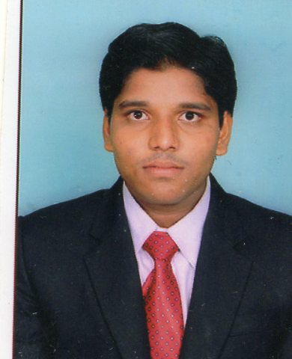
BRUNGA SRIKANTH
Email.id: Srikanthvarma103@gmail.com
Contact no:8328330013,9912745858
CAREER OBJECTIVE
To work with an organization that would give me an opportunity for personal growth and enhance my professional skills in the service industry.
EDUCATIONAL QUALIFICATION
Course | Board/University | Institute | Year of pass | Percentage
BHM | ACHARYA NAGARJUNA UNIVERSITY | NIHM, NARASARAOPET | 2016 | 82%
Intermediate | Board of Intermediate | A.P.S.W.R.S & JR.COLLEGE,  KAREMPUDI | 2013 | 80%
SSC | Board of Secondary education | A.P.S.W.R SCHOOL  KAREMPUDI | 2010 | 70%

AREA OF INTREST
- HOUSEKEEPING
KEY SKILLS
- I can communicate in English and Hindi and Telugu

STRENGTHS
- I can mould myself for the welfare of growth in the field.
- I can easily adopt in any environment.

INDUSTRIAL EXPLOSURE TRAINING
Name of the property: TAJ GATEWAY VIJAYAWADA.
- Duration: 16 weeks (10.04.2015– 10.08. 2015

INDUSTRIAL EXPERIENCE

- Feb 18th 2016 to 31st march 2017 worked as HOUSEKEEPING supervisor in Swagath grand Hotel
- April 05th to present i am doing in Sagar hospital as Housekeeping supervisor

PERSONAL DETAILS
Name : BRUNGA SRIKANTH
Father’s Name : VENKATA NARASAIAH
Date of Birth : 15-06-1996
Hobbies : Listening to music, playing games.
Address : H. No:4-342/1 OPPICHERLA(V),
KAREMPUDU (M)
GUNTURE (District)
Nationality : Indian
Languages known : English, Telugu,Hindi
DECLARATION
I hereby declare that the above mentioned information is true to best of my knowledge and I bear the responsibility for the commitment for the above mentioned particulars.

B.SRIKANTH

